Tech Saksham

Case Study Report

Data Analytics with Power BI

# “Supply Chain Analysis of Inventories”

### GOVERNMENT ARTS AND SCIENCE COLLEGE FOR MEN KRISHNAGIRI

|  |  |
| --- | --- |
| NM ID | NAME |
| 1BB8967B040063D94AF40A4CF1C9774C | GOKUL V |

**Trainer Name:** R UMAMAHESWARI

**Master Name:**R UMAMAHESWARI

# ABSTRACT

While the complexity of supply chainsincrease, market power is more often centralizes to a few players within the chains. As an amorphously onstructed term, the concept of power has become a research objective in certain areas. Nevertheless, there need to be more empirical improvements in the research area of supply chain management (SCM). This research aims to close the gap by using qualitive data and developing a literature-based, empirically proven model assumption about how digitalization influences the mechanisms of power in SCM. A category system and theoretical assumptions are proposed based on a qualitative study comprising 15 expert interviews with senior supply chain managers and executive managers. This paper provides an overview toestablish a more profound understanding of how the power mechanisms are substantiated in the supply chains and points out different influence strategies in SCM concerning the digitalization of the chain. Therefore, it offers a framework for how digitalization influences the power structures in the supply chain compared to the theoretical understanding of power in SCM.

# INDEX

|  |  |  |
| --- | --- | --- |
| **S.No** | **Table of Contents** | **Page No.** |
| 1. | INTRODUCTION | 4 |
| 2. | LITERATURE REVIEW | 6 |
| 3. | CASE DESCRIPTION | 7 |
| 4. | ABC ANALYSIS | 11 |
| 5. | RESULT AND DISCUSSION | 14 |
| 6. | CASE ANALYSIS AND DISCUSSION | 16 |
| 7. | DASHBOARD | 18 |
| 8. | RESEARCH METHODOLOGY | 19 |
| 9. | CONCLUSION | 21 |
| 10. | REFERENCE | 22 |

**INTRODUCTION**

### Background

Traditionally, companies in a supply chain network focus mainly on their own processes and pay less attention to their suppliers or customers. However, globalization and the development of intensive relationships among companies have induced paradigm shifts in modern business management, including the management of supply chain networks (Lambert et al., 2000). Since holding inventory is expensive, effective inventory management is critical to supply chain operations.

Uncertain demand and economies of scale underline the importance of keeping some inventory.

However, different functions of a company may disagree over inventory level. Marketing may want to keep inventory as high as possible, so that customers’ demand can be satisfied immediately. Production may also want to maintain a high inventory to support long production runs and to realize economies of scale. Finance, however, may prefer a low inventory to reduce the current asset levels. Obviously, such conflict generates a question: what level of inventory should we maintain in order to simultaneously satisfy customers’ demand and minimize operational costs?

Many foreign manufacturers in China have faced similar problems and this undermined their efficiency badly. Therefore, how to optimize inventory is a crucial issue that needs to be resolved. This paper aims to discuss the issue by analyzing the case of a selected company in order to suggest waysto tackle the issue using inventory management tools, such as the safety stock model.

### Problem statement

The company selected for this case study is a foreign direct investment manufacturer headquartered in Germany, to which we have assigned the pseudonym R&D. It is in fact one of the largest manufacturing companies in the world producing electronic components, modules and systems. It has approximately 26,300 employees in its 20 different locations engaged in design and production. A comprehensive range of products are offered by R&D in the areas of information and communication technology, automotive electronics, industrial electronics and consumer electronics.

R&D’s manufacturing locations and sales offices are distributed widely: from Europe, to Asia, to South and North America. The main production branch, which is located in Zhuhai, Guangdong province, makes piezo and protection devices, film capacitors and sensors. The Zhuhai factory has approximately 2,800 employees and was founded in 1998. On one hand, the broad diversification of products offers customers a range of choices and increases the company’s market share, but stocking up on materials in preparation for uncertain demand and new project roll-outs have led to inventory management problems, including:

1. Early inventory with high service level.
2. Late inventory with low service level.

There are several reasons why we chose this company as a case study. First, R&D is representative of most foreign direct investment companies because it is an electronic components manufacturer that depends heavily on manpower. Second, this company used one of the most popular enterprise resource planning (ERP) systems — SAP — carry out customer order planning and inventory evaluation. It is a relevant for investigating information system application and inventory management tools.

# Literature View

Traditionally, supply chain management is viewed as a vertical integration of marketing, distribution, planning, manufacturing, and purchasing departments within an organization. Beamon (1998) divided a supply chain into two integrated processes: production planning and inventory control process, and distribution and logistics Process. The processes and movements of raw materials into finished products are illustrated in Figure 1.

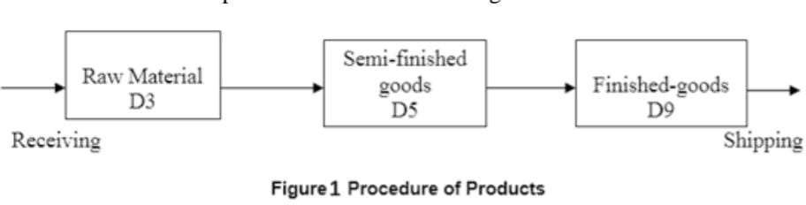

With the development of supply chain management, advanced modeling approaches have been used to improve the efficiency of supply chains. Williams (1981) developed a dynamicprogramming algorithm which can minimize the average costs per period over an infinite horizon. Ishii et al. (1988) developed a deterministic model to prevent stock outs and minimize the amount of inventory. Newhart et al. (1993) designed an optimal supply chain to minimize the number of distinct product types held in inventory. Inventory holding costs can be between 20 to 40 percent of their values, so efficient inventory management is crucial in supply chain operations. Ballou (1998), Lin and Huang (2014) indicated that inventory management is a balance between customer service, product availability and the cost of inventory. Many companies working on inventory management recognize that too much inventory represent high risks and high costs. As shown in Figure 1, the channel from suppliers and manufacturers to distributors and retailers involves different kinds of inventory. Simchi-Levi et al. (2003) and Muniappan et al. (2016)

explained the reasons why companies need to hold inventory, including unexpected changes in customer demand, uncertainty in the quantity and quality of supplies, lead times and economies of scale. Having considered the importance of inventory, it is necessary to define factors that determine inventory costs.

Chopra et al. (2007) divided the inventory costs into three parts: material costs, holding costs and ordering costs. There is some tradeoff between the cost of investing in and holding excess inventory. We need to buffer the effects of both demand uncertainty and production lead time. Fitzsimmons et al. (2001) introduced the notions of safety stock level and reorder point to deal with such problems. Safety stock is a level of extra stocks that is maintained to overcome uncertain demand and supply. Kouki et al. (2016) pointed out that an effective safety stock can help to prevent stock outs by combining cyclical volume planning and fair share mix decisions. The higher the level of safety stock a company keeps, the better it can satisfy its customers, but the more it costs to maintain its service level. Whenever stocks fall below specific level, the factory needs to reorder. The timing of the reorder is important: an early one will build up extra stocks, while a late reorder will reduce service level. Cachon et al. (2000) and Baralis et al. (2015) indicated that reorder point policies were optimal in a serial supply chain with batch ordering.

# CASE DESCRIPTION

## Company background

Being one of the top manufacturers of passive electronic components, R&D offers a broad portfolio including thermistors, disk varistors and multilayer varistors. These temperature- and voltage-dependent resistors are

used mainly in automotive, industrial and consumer electronic appliances, where they are used either for protection or heating functions. Surge arresters – another ceramic protection device – mostly guard telecommunication systems against voltage surges, such as those that occur when lightning strikes.

R&D has more than 40 affiliates around the world but this paper, as noted earlier, focuses on R&D Zhuhai. For storing finished goods and raw materials, there is one warehouse in R&D(FTZ Zhuhai), which is located opposite to the manufacturing building. Besides the warehouse, there are also buffer areas to load and unload finished goods and raw materials. One of the major products is the leaded varistor, with a production capacity per month of over 100 million units. The varistors take the forms of raw material (D3), semi-finished goods (D5), and finished goods (D9), all of which are found in the inventory. In the Ceramic Components segment, operating profits declined in the period under review to EUR 37 million (2011: EUR 57 million). The main reasons were the decline in sales and higher material costs, especially for metals.

This paper will analyze the inventory of one product, leaded varistors, which occupies an important role in R&D Zhuhai for its high capacity and standard production procedures. It is a good case to analyze since inventory influences production performance greatly. R&D Zhuhai uses one of the most popular enterprise resource planning (ERP) systems, SAP, to do customer order planning and evaluate inventory. R&D Zhuhai has employed the SAP module since 2013 but has encountered various problems in customizing SAP The approaches adopted for dealing with such problems are relevant to our analysis.

## Product information

Leaded varistors are made from a kind of granule, D3 (see Figure 2 below). D3 raw material is stored in the warehouse and delivered to the receiving area. Then it will be pressed and sintered at high temperature into a fix mold, which we refer to as D5. It will then be modeled into the required shape at the production plant and converted into the finished product, D9. The finished goods, D9, will be sent to the warehouse and then delivered to the relevant customers. R&D needs to control its inventories at all three production stages.

Procedures work like this at the moment:

1. the materials planning department checks with SAP to find out how much of each material is left in the warehouse.
2. The materials planner estimates the amount of production needed and submits a purchasing order to vendor.

The estimation is based on the historical data and the past long-term forecasting practices. Sometimes, the materials cannot be able to arrive as expected due to some reasons and this will cause production to decline or stop. so safety stock is necessary for such materials but materials stockpiled in this way occupy most of the warehouse. There are two ways to solve this problem. One is to strengthen the communication between production plant and the material planner so that both know when and how much stock will be needed. The other way is to consume the extra stock by producing more D5. Moreover, the relationship between D3 and D5 is one to many, which means that one specific D3 can produce several kinds of D5 as illustrated in Figure 2. But this may transfer inventory pressure onto D5 stock and produce more work in process (WIP) inventory. Therefore, the pull strategy, which produces according to customer demands, plays an important role in such situations. Extra D5

cannot be produced if customers do not demand it or if the warehouse has no space to store it.

Another issue involves monitoring the inventory. The relationship between D5 and D9 is one to many as illustrated in Figure 2. In other words, D5 is the raw material of D9. The inventory control of D5 is different from that of D3 because holding costs are higher and it directly influences the production of D9. If the stocks of D5 cannot be consumed, it will become dead stock. Obviously, D9 demand is the key factor determining the stock of D5. D9 stock levels are based on the orders in hand and the experience of MRP controllers, who decide how much of each product needs to be produced. Under R&D’s pull strategy, D9 safety stock is seldom build up. Sometimes this will affect service level since the strategy cannot meet short notice orders.

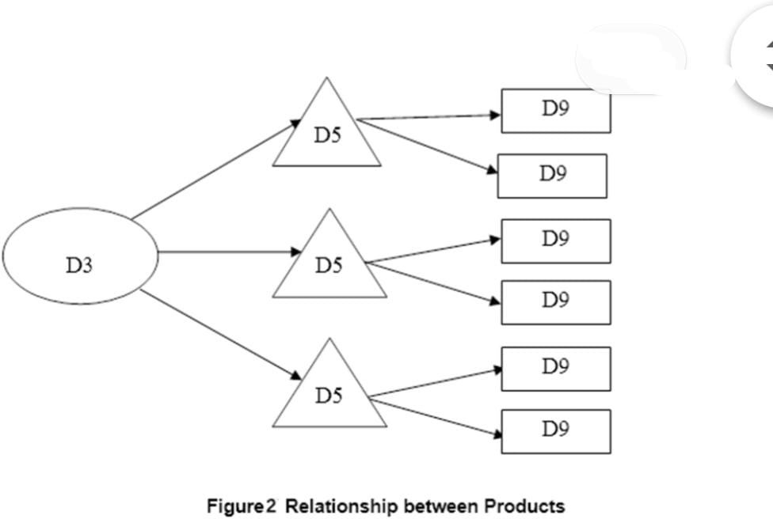

## ERP system and information sharing

The ERP system used in R&D is SAP R/3, one of the most popular and practical ERP systems in the world. SAP R/3 consists of a range of

modules: sales and distribution, materials management, production planning, quality management, plant maintenance, warehouse management, financial accounting, control, asset management, human resource, workflow model and project system. R&D bought five modules: material management, production planning, sales and distribution, financial accounting and control. Some functions of R&D’s SAP are unique to assure the convenience and accuracy of operations. Therefore, SAP plays an important role in R&D’s overall production procedures.

At the same time, R&D is a global company where information is difficult to share without a proper communication platform. Once you have a SAP account, you can access the information you need wherever you are. However, to avoid too much information exposure to each one, there is an authorization limit on users so that, SAP offers both a platform for global information sharing and has its own way of protecting procedures.

# ABC ANALYSIS

This case study is developed from actual data gathered from the company. However, in order to protect the interests of the company so that the company identity remains anonymous, we use PISB (pseudonym) as a company’s name throughout the study. PISB is one of the manufacturers producing the healthcare and cosmetic products. PISB had registered as an SME of the pioneer manufacturer and distributor of health products, traditional medicines and cosmetic products using herbal and sea cucumber (gamat) as the active ingredients. PISB had been selling their products in a variety of retail stores covering almost all over in Malaysia. By the year 2005, PISB produced a total of 128 products. These products were separated into four categories as listed below: i) Healthcare Product



1. Cosmetic Product
2. Oily and Balm Product
3. Herbs Medicinal Product

As the company operates with hundreds of products, it is good to cut the quantity of goods to the most essential ones. Undoubtedly, that main product is traditional medicines and healthcare products. Within current research following key indicators are selected: total year revenue, one item sales price and total amount of sales. Based on 2014 production data, the list of PISB products consists of 43 items (some items are grouped before the analysis, as well some seldom and special items are ignored as not typical in daily operations). However, for the ABC analysis, we have selected only 22 items because of some items have not sufficient data information. ABC classification by total year revenue is very essential for the company as it shows items which require most assets into inventory. These items should be controlled as tight as possible, i.e. low inventory levels and safety stocks to minimize costs. Performing ABC classification by price is less important than total year revenue, however is still useful. As group A needs a high level of safety to protect it from any damage. ABC classification by demand has a similar nature with classification of total year revenue. Besides, group A items should be held in the most accessible place in the warehouse as they are the most demanded.

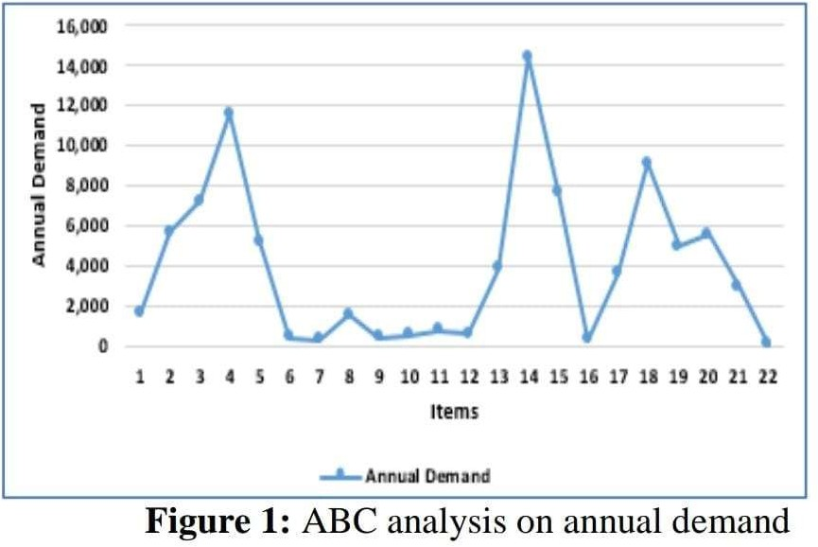

An illustration of ABC analyses is shown in Figure 1 and Figure 2. For comparing analysis, we can conclude that both ABC analysis of annual demand and annual cost show almost the same result, which is close to theoreticalABC breakdown. In spite of the items in both Groups A are almost the same, they have different ranking. ABC analysis by items total price shows different results as the nature of key parameter is different. The most essential items for the company based on ABC analysis JeliPatiGamat, Krim Seri Gamat, MinyakBelacak, Balsam Serai, PISB Seri Wajah and Minyak Seri Gamat.

Figure 2: ABC analysis on annual cost

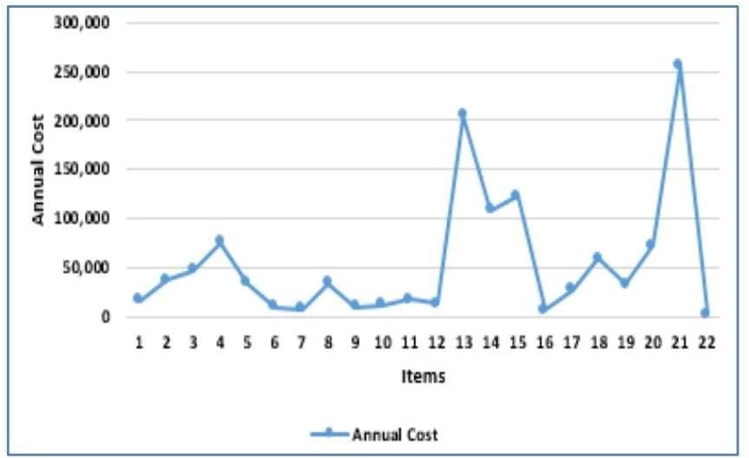

Furthermore, Table 1 below shows data collection for the PISB products. Column 1 of Table 1 shows the items names, whereas the column 2 represents the annual demand of the respective item. Column 3 represents the annual percentage of the respective item, whereas the unit cost is mentioned in column 4. The respective item annual cost is indicated in column 5 of Table 1. For ABC analysis, annual cost, annual usage percentage and annual usage cumulative percentage are the deciding factors. These factors are shown in column 6, 7, and 8 of Table 1 respectively. The items are classified on the basis of the steps mentioned below: i) Categorise items and find its use in units and unit price.

1. Find the total value of every item by taking the product of the expected units by its unit price.
2. Rank the item according to the highest total value.
3. Compute the percentages of the number of units of each item to total units of all items and the ratio of the total value of each item to the total value of all items. v) Add together the items on the basis of their relative value to form A, B and C categories.

# RESULT AND DISCUSSION

A total of 22 items were analysed as shown in Table 2 which are seven items as are categorized in Class A, eight items are categorized in Class B whereas seven items are categorized in Class C. TonikHerbaGamat (Sea Cucumber), JeliPatiGamat (Sea Cucumber), MinyakBelacak (Massage Oil) and Krim Seri Gamat (Cream & Balm) are among the highest by total year revenue which are categorized in Class A. While most of the herbal capsules products are categorized in Class C. Moreover, 1 sea cucumber product, 2 massage oil products, 3 cream & balm products and 2 herbal capsule products which are in medium values of annual sales is kept under a category B.

**Table 1: ABC analysis based on total year revenue**

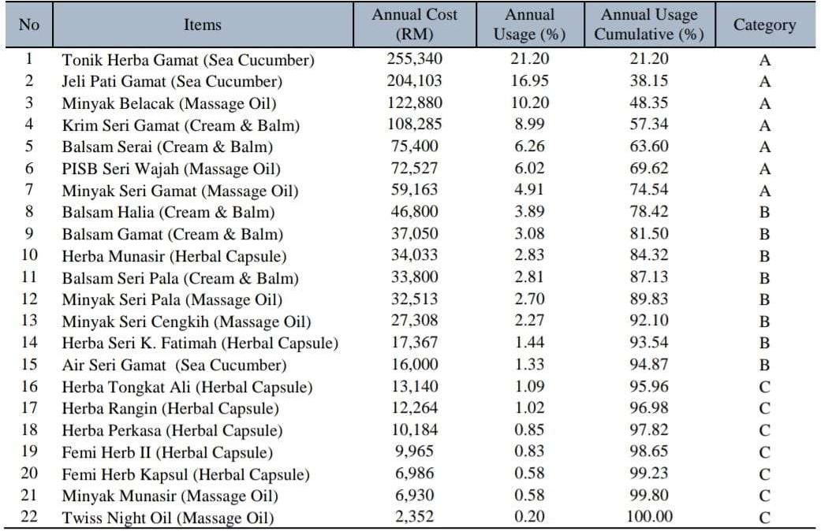

# CASE ANALYSIS AND DISCUSSION

### 6.1Supply chain strategy and postponement

Placing orders has a cultural aspect: European customers like to plan in advance, even a year ahead, and so they will normally place orders within lead time. Some customers that have long term demands placed orders one year ahead, and then reviewed the actual demand monthly. The non-European customers, on the other hand, including those from America, Australia, Africa, Hong Kong, China, and Taiwan etc., tend not to place long term orders. In other words, the risk of building inventory is high because uncertainty of demand is relatively high. As customer demand reflects orders on hand, R&D applies the pull strategy for finished goods.

How to balance the tradeoff between inventory and economies of scale? On one hand, R&D arranges production according to orders on hand. If demand were less than lot size, production would produce the amount of one lot size. If demand were higher than one lot size, production would produce the quantity that meets the customer’s requirements. Generally speaking, MRP controllers arrange production according to their experience and historical demand data, but this can hardly define how many items should be kept as safety stock and there are no pre-determined instructions from the management.

The planning for raw materials is based on the demand for semi-finished goods. With the help of SAP, material planners aggregate information on both the finished goods semi-finished goods. However, the high scrap rate and long lead time of production make planning difficult. Moreover, it costs less to purchase huge quantities of raw material abroad via sea freight transportation. Thus, R&D applies a push strategy to arrange the purchase of raw materials. Sometimes stocks of raw material are plentiful, but sometimes, raw materials will be in shortage and this make the production line halt temporary, which wastes both capacity and time. Safety stock is built up but no one knows how much is appropriate and when to build it up.

In sum, we can see that R&D uses three strategies to arrange productions, as illustrated in Figure 5.

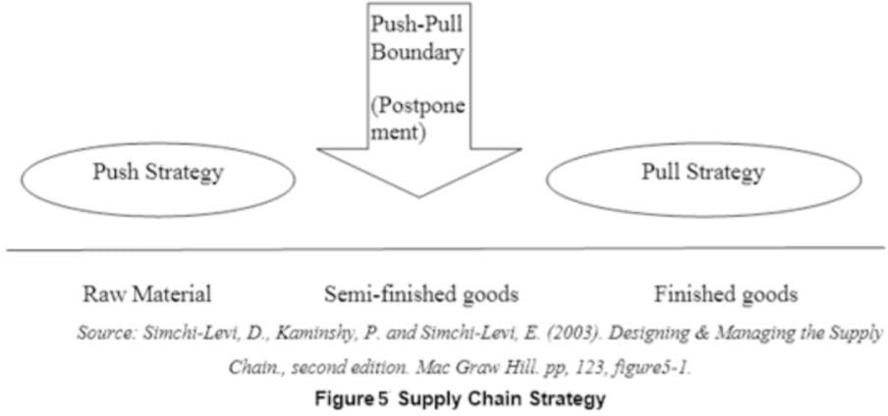

# DASHBOARD

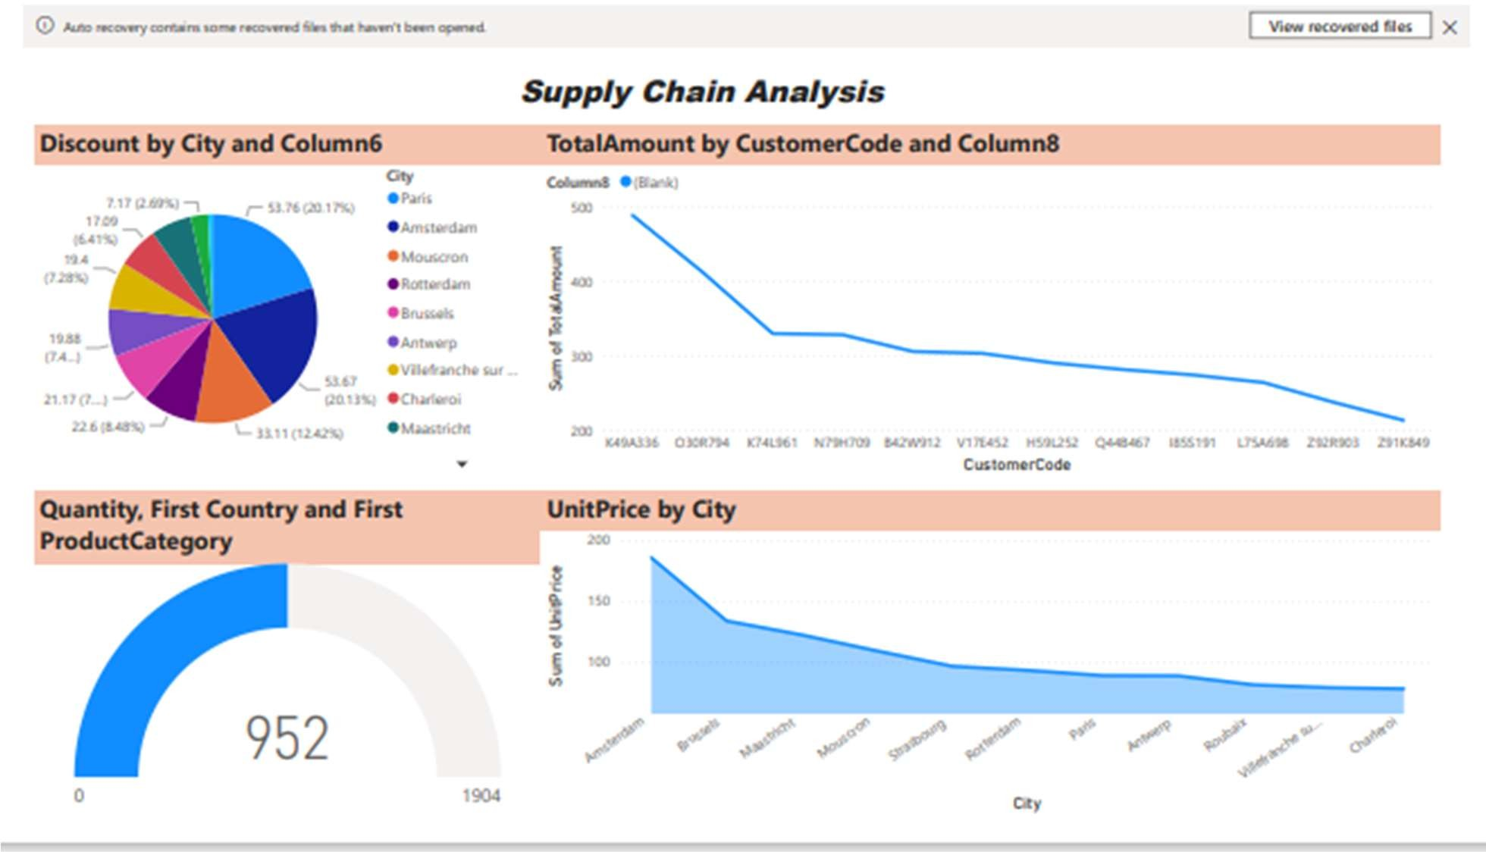

SUPPLY CHAIN ANALYSIS DASHBOARD 1&2

# RESEARCH METHODOLOGY

In this study, case study research method is applied. Both quantitative and qualitative inventory management methods have been examined in the case analysis. Quantitative methods employ mathematical models to manage inventory, while qualitative methods use conceptual ideas from supply chain management to reduce inventory. It is expected to arrive at a deep understanding of how inventory management is done, and what factors influence the efficiency and effectiveness of inventory management to reduce costs, improve service, and enhance competitive advantage. In this paper, we have focused on ABC analysis for analysing of inventory management in a healthcare product manufacturing company. Firstly, we visited the company for data collection. The data collected by interviewing managers and his staff who are involved in inventory management. Other data are collected by studying company documentation, such as production schedules, inventory reports, production reports, ERP databases, and public media such as the internet and newspapers. Then, the raw data were filtered into required information. Figure 1 shows the overall methodology decided for this paper. After data collection, with the help of Microsoft Excel, the ABC analysis was performed.

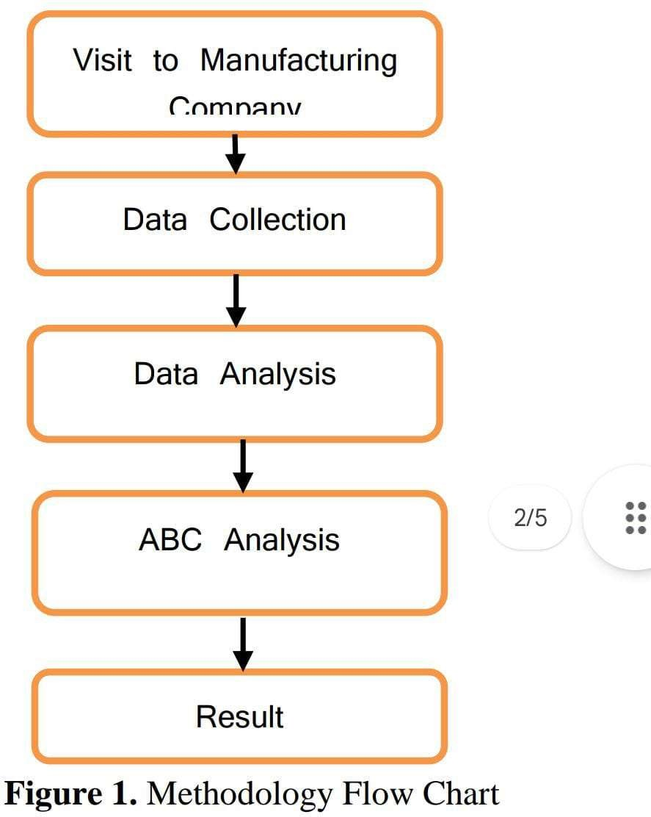

# CONCLUSION

This paper analyzed a company’s inventory strategy and management tools as an example to explain similar inventory problems encountered by manpower-intensive industries in China. By combining classical inventory models such as safety stock and ROP, this paper aimed to arrive at the optimal inventory level while maintaining a consistently good service level. The paper also discussed approached to inventory management such as postponement and VMI.

Though R&D is well-equipped with tools to manage its production and inventory, it still needs to build up safety stock in a better and cheaper way. Currently, R&D monitors inventory mainly by manual effort and does not make the most of available cross-platform automatic systems. Though the two kinds of postponements confer great benefits on R&D and save it a great deal of money, manual work is demanded from MRP controllers to maintain systems and monitor inventory levels.

The trade-off between inventory and service level is a never ending topic. It is difficult to decide which is more important. Management is the key factor that instructs employees how to set appropriate priorities. Nevertheless, R&D needs to improve operational processes and standardize them so that manual mistakes can be reduced.

The findings of this paper are based on a single year’s data only and this places limitations on the validity of outcomes. However, there will be many opportunities for further research and by collecting more data, we can identify other related variables which can optimize inventory level and raise service level. We can also focus in future on knowledge management and customer relationship management.

# REFERENCE

### Ballou, R. H. (1998). Business logistics management (4th ed.). London: Prentice-Hall.

1. Christopher, M. (2016). Logistics and supply chain management (5th ed.). Harlow: Pearson Higher Education.

### Rahim, M. K. I. A., &Aghezzaf, E. H. (2012). Implementing a vendor managed inventory policy in a two-stage supply chain with stochastic demands. In 14th IFAC Symposium on Information Control Problems in Manufacturing (INCOM-2012) (pp. 602-607).

1. Radzuan, K., Rahim, M. K. I. A., Anuar, H. S., Nawi, M. N. M., & Osman, W. N. (2015). Inventory Management Practices and Its Effects on Vendor Managed Inventory Performance. Advanced Science Letters, 21(6), 2114-2117.
2. Wei, Y., Wang, H., & Qi, C. (2013). “On the stability and bullwhip effect of a production and inventory control system”, International Journal of Production Research, Vol. 51, pp.154-171.